|  |
| --- |
| [Moster_G] |
| Slot Machine |
| [Earning money] |
| Version #1.2  All work Copyright © 2016 by Monster_G.  All rights reserved. |
| **[Giho Kim #300738697]** |
| **Giho Kim** |



|  |
| --- |
| Feb 29th 2016 |

**Table of Contents**

1. **Version History**
2. **Captured image (Intro)**
3. **Game Information**
4. **Game Description**
5. **Game Play Mechanics**
6. **Controls**
7. **Interface Sketch**
8. **Screen Descriptions**
9. **Scoring**
10. **Multimedia Index**
11. **Github Information**
12. **Version History**

|  |  |
| --- | --- |
| **Version** | **Description** |
| 0.1 | Initial draft of SlotMachine |
| 1.0 | Complete Spin Function |
| 1.1 | Add more functions and effects |
| 1.2 | Final version |

1. **Captured image**

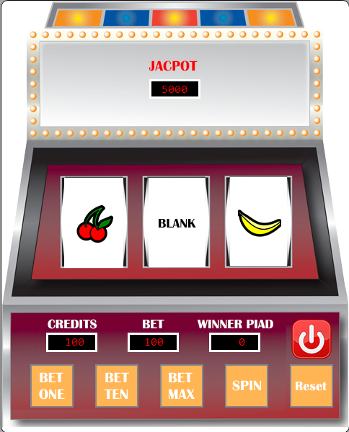

1. **Game Information**
2. **Game Description**

* *The game is played by wagering credits on the spinning reel and pulling a handle that activates a set of spinning symbols on wheel. The current credits meter will be displayed on the screen, as well as the credits bet and the credits won in the game. A user will win diverse credits based on the bet credits and can get the biggest prize when three matching symbols hit across the line.*

1. **Game Play Mechanics**

* *The basic way that a slot machine works is by using a random number generator. With the random number, the program of slot machine will determine array of symbols and then, will spin the symbols in different speed to get various results of set of the symbols. As soon as the player clicks spin button on the slot machine, the programmed process begins immediately and the program will calculate user win or lose based on the result of symbols. In case of user win, it will offer the accurate amount of prize as well.*

1. **Controls**

* *Control user credits by checking current user credits and bet credits as well as result of previous game. The slot machine will ask a user lower bet credits or even resetting credits if the user does not have enough credits.*

1. **Interface Sketch**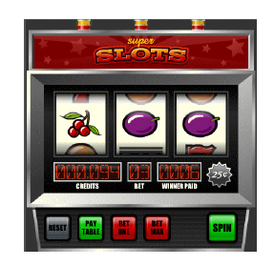
2. **Screen Descriptions**

* **Bet buttons as One, Ten and Max**
* **Spin button**
* **Reset button**
* **4 labels to display credits bet winner paid and jackpot**
* **Three reels**
* **Power button**

1. **Scoring**

|  |  |
| --- | --- |
| **Combination** | **Winner paid** |
| **3 peach symbols** | **User bet * 10** |
| **3 banana symbols** | **User bet * 20** |
| **3 orange symbols** | **User bet * 30** |
| **3 plum symbols** | **User bet * 40** |
| **3 bar symbols** | **User bet * 50** |
| **3 lemon symbols** | **User bet * 75** |
| **3 seven symbols** | **User bet * 100** |
| **2 peach symbols** | **User bet * 2** |
| **2 banana symbols** | **User bet * 2** |
| **2 orange symbols** | **User bet * 3** |
| **2 plum symbols** | **User bet * 4** |
| **2 bar symbols** | **User bet * 5** |
| **2 lemon symbols** | **User bet * 10** |
| **2 seven symbols** | **User bet * 20** |
| **Jackpot** | **5000 credits** |

1. **Multimedia Index**

|  |  |  |
| --- | --- | --- |
| **Division** | **Image** | **Description** |
| **Symbol** |  | **Banana** |
|  | **Cherry** |
|  | **Grapes** |
|  | **Orange** |
|  | **Blank** |
|  | **Bell** |
|  | **Bar** |
|  | **Seven** |
| **Button** |  | **Power** |
|  | **Reset** |
|  | **Bet One** |
|  | **Bet Ten** |
|  | **Bet Max** |
|  | **Spin disabled** |
|  | **Spin** |

1. **Github Information**

*Url:*

*Git Hub:* <https://github.com/kkh0811/Assignment2_SlotMachine.git>